Final Year Project



Software Requirement Specification BioMechAI
FYP Team
Muhammad Abdullah (22F-3444) Muhammad Abdul Hanan Nadeem (22F-8762)
Zainab Haider (22F-8818)

Supervised By
Mr. Mughees Ismail

Co-Supervised By
Dr. Muhammad Usama


Department of Computer Science
FAST – National University of Computer & Emerging Sciences Chiniot-Faisalabad Campus
2026

Table of Contents

- Introduction 1
- Vision Document 2
  - Problem Statement: 2
  - Business Opportunities 3
  - Objectives 3
  - Scope 4
  - Constraints 4
  - Stakeholder and User Description 4
    - Market Demographics 4
    - User Environment 5
    - Stakeholder Profiles 5
    - Stakeholder Summary 7
- System Requirements Specification 8
  - System Features 8
  - Functional Requirements 9
    - Real-time 3D Pose Detection 9
    - Exercise Recognition and Classification 9
    - Real-time Rep Counting and Form Validation 9
    - Posture Correctness 10
    - Body Measurement and Transformation Tracking 10
    - AI Injury Prediction 11
    - AI Workout Companion with Voice Conversation 11
    - Trainer Dashboard 11
  - Non-Functional Requirements 12
    - Performance 12
    - Usability 12
    - Reliability 12

    - Security and Privacy 12
    - Compatibility 12
- Project Artefacts 13
  - Use Case Models: 13
  - Structural Design: 27
  - Behavioral Design: 30
  - Maintenance Phase 33

List of Tables:
Table 1: Problem Statement 2

Table 2: Supervisor Team 5

Table 3: Development Team 5

Table 4: End Users 6

Table 5: Certified Trainers 6

Table 6: Admin 7

Table 7: Stakeholder Summary 7

Table 8: Register and Login User 14

Table 9: Track Body Measurements 14

Table 10: Detect Real-Time 3D Pose 15

Table 11: Recognize Exercise 15

Table 12: Assist Via Voice 16

Table 13: Provide Posture Correction and Feedback 16

Table 14: Count Reps and Validate Form 17

Table 15: Predict Injury 17

Table 16: Manage User 18

Table 17: View Reports 18

Table 18: Access Trainer Dashboard 19

Table 19: High-Level Use Case 19

List of Figures:
Figure 1: Use Case Diagram 13
Figure 2: Swimlane Activity Diagram 21
Figure 3: System Sequence Diagram 01 - Body Measurement Tracking 22
Figure 4: System Sequence Diagram 02 - Exercise Recognition 22
Figure 5: System Sequence Diagram 03 - Injury Prediction 23
Figure 6: System Sequence Diagram 04 - Pose Detection 23
Figure 7: System Sequence Diagram 05 - Posture Correction 24
Figure 8: System Sequence Diagram 06 - Rep Counter 24
Figure 9: System Sequence Diagram 07 - Trainer Dashboard 25
Figure 10: System Sequence Diagram 08 - User Registration and Login 25
Figure 11: System Sequence Diagram 09 - Voice Companion 26
Figure 12: Domain Model 27
Figure 13: Class Diagram 28
Figure 14: Component Diagram 29
Figure 15: DFD Level 0 30
Figure 16: DFD Level 1 30
Figure 17: State Machine Diagram 31
Figure 18: Sequence Diagram 32
Figure 19: Deployment Diagram 33

Introduction
BioMechAI is created to solve an important problem in personal fitness: many people do not have an easy way to check whether they are performing exercises with the correct form in real time, which can increase the chances of workout-related injuries. This section introduces the main goals and reasons behind developing this system.
In addition, this Software Requirements Specification (SRS) clearly describes the system’s functional requirements (what the system should do) and non-functional requirements (how well the system should perform). It also includes the use case models and the guidelines for designing artifacts that will be used while building the BioMechAI system. For the mid-evaluation stage, the project is divided into the following nine modules:
- Module 1: User Registration and Login
- Module 2: Real-time 3D Pose Detection
- Module 3: Exercise Recognition and Classification
- Module 4: Real-time Rep Counting and Form Validation
- Module 5: Posture Correctness (Four-Pattern Form Correction)
- Module 6: Body Measurement and Transformation Tracking
- Module 7: AI Injury Prediction
- Module 8: AI Workout Companion with Voice Conversation
- Module 9: Trainer Dashboard.

Vision Document

Problem Statement:
Table 1: Problem Statement

Category | Description
Problem | Personal training sessions are expensive, and many users cannot afford them, as a single session can cost a large amount of money.  Around 45% of people who go to the gym experience injuries because they perform exercises with the wrong form and there is no system to correct them instantly.  Most fitness applications only provide general workout plans. They are not personalized and do not give real-time 3D feedback about body movement during exercises.
Affects | People of all fitness levels who want to exercise safely and improve their training.  The wider health and fitness community, including physiotherapists, fitness coaches, and sports medicine professionals.
Impact | Leads to avoidable injuries, extra medical costs, and people training on their own without proper guidance.  Creates a gap in preventive health because there are very few affordable tools that combine movement analysis with personalized coaching.
Solution | An AI-powered personal fitness trainer that works on a smartphone and uses real-time movement analysis. The system will:  Provide real-time 3D pose correction and recognize the exercise being performed.  Automatically count repetitions while checking if the exercise form is correct.  Analyze movement patterns during workouts to predict possible injury risks.  Include an AI voice companion that can talk with the user and give personalized workout guidance.  Work completely on normal smartphones so users do not need expensive or specialized equipment.

Business Opportunities
BioMechAI aims to solve an important problem in accessible personal fitness while also creating a strong business opportunity. The system can support a premium subscription model for users and also allow partnerships with rehabilitation clinics, sports academies, and corporate wellness programs. Through these partnerships, this application can provide scalable AI-based coaching that analyzes body movement and exercise form.

Objectives
Following are the objectives of BioMechAI:
- Develop a real-time 3D pose detection system that can run smoothly on
normal smartphones and accurately track the user’s body movements.
- Implement automatic exercise recognition so the system can identify different workouts without the user needing to select them manually.
- Provide a form validation system that checks movement patterns to make sure exercises are performed safely, with correct posture, and flags movements that may cause injury.
- Allow users to monitor their physical progress through a body measurement and transformation tracking feature that uses 3D body modeling.
- Build an AI-based injury prediction system that studies movement changes over time and warns users about possible injury risks before they happen.
- Introduce a conversational AI voice companion that gives users real-time coaching, motivation, and feedback while they are exercising.
- Provide certified personal trainers with a dedicated dashboard so they can manage, review, and guide their remote clients using AI-supported workout videos.
- Use optimization methods so that all AI models run efficiently and respond in real time on mid-range smartphones, ensuring a smooth experience.

Scope
The scope of BioMechAI includes developing a complete personal fitness platform that focuses on real-time 3D body movement analysis, exercise recognition with form checking, AI-based injury prediction, and conversational coaching. In the beginning, the system will be designed to run on both web and mobile platforms.

Constraints
- All AI processing must finish within 100ms on mid-range devices (equivalent to Snapdragon 720G or better).
- AI model sizes must stay under 50MB on the device after INT8 quantization to comply with app store limits.
- During academic testing, the Firebase free tier restricts the number of concurrent users to about 50-100 active users.
- LLaVA-1.5-7B runs in the cloud on Google Colab, which can cause 500ms-1s delays for complex AI companion responses.
- The accuracy of body measurement depends on the quality of 2D images,
lighting conditions, and the user’s clothing.
- Injury prediction requires at least 30 workout sessions before it can provide reliable risk assessments.

Stakeholder and User Description

Market Demographics
The primary target market for this app includes fitness-conscious individuals aged 16 to 45 who exercise on their own, either at home or in gyms, without regular access to personal trainers. Secondary markets include certified fitness trainers who want AI-assisted tools to manage and monitor clients, physiotherapists who use movement analysis for rehabilitation, and sports academies focused on tracking athletes’ form and performance. In Pakistan and South Asia, BioMechAI’s smartphone-based approach makes professional fitness guidance more affordable, helping users overcome economic barriers.

User Environment
End users interact with BioMechAI through the Flutter mobile app on Android or iOS smartphones. They perform workouts in different settings such as homes, gyms, or outdoor spaces, with the phone placed 1.5-3 metres away on a stand or flat surface. Trainers access the system using web portal on desktop browsers like Chrome, Firefox, or Safari. Most AI processing happens directly on the device, while cloud services like LLaVA and Firebase need a stable internet connection. If the connection is weak, the system continues to work by disabling cloud-based voice features and relying on on-device models for essential functionality.

Stakeholder Profiles
      - Supervisor Team
Table 2: Supervisor Team

Representatives | Supervisor: Mr. Mughees Ismail  Co-Supervisor: Dr. Muhammad Usama
Description | Supervise development activities and ensure academic standards are maintained
Type | Technical Stakeholders
Responsibility | - Give directions to the development team  - Ensure timely completion  - Review project deliverables and documentation  - Track development tasks  - Ensure product meets academic standards
Success Criteria | Completion of features committed by the development team at the start of the project
Involvement | - Requirement reviewer  - Senior managers  - Review project progress
Comments/Issues | None
      - Development Team
Table 3: Development Team

Representatives | Muhammad Abdullah, Muhammad Abdul Hanan Nadeem, Zainab Haider
Description | Responsible for full development, documentation, testing, and deployment of BioMechAI
Type | Technical stakeholders

Responsibility | - Develop the system across mobile and web platforms  - Create and maintain comprehensive documentation  - Test AI models and app features  - Deploying the final product
Success Criteria | Deliver a fully functional, responsive application that meets all functional and non-functional requirements
Involvement | - Full involvement in all phases of SDLC  - System design and implementation  - Quality assurance and debugging
Comments/Issues | None
      - End Users
Table 4: End Users

Representatives | General public / Fitness enthusiasts
Description | Primary users utilizing the mobile app to exercise safely and track physical progress
Type | Non-technical Stakeholders
Responsibility | - Use app for real-time fitness tracking and form validation  - Provide feedback on usability and features  - Report operational issues
Involvement | - Beta testing  - User Acceptance Testing (UAT)  - Providing usability feedback
Comments/Issues | None
      - Certified Trainers
Table 5: Certified Trainers

Representatives | Professional fitness coaches
Description | Fitness professionals using the web-based Trainer Dashboard to remotely manage clients
Type | Domain-expert Stakeholders
Responsibility | - Monitor remote clients’ workout progress  - Review AI annotations and 3D pose data  - Generate performance reports and adjust training plans
Involvement | - Beta testing of the web portal  - Validation of four-pattern form correction
Comments/Issues | None

      - Admin
Table 6: Admin

Representatives | Admin
Description | Oversees backend operations, database management, and system stability
Type | Technical Stakeholder
Responsibility | - Manage user and trainer accounts  - Monitor system health, Firebase usage, cloud latency  - Ensure data security and backend stability
Involvement | - Backend administration  - System and database monitoring  - Deployment maintenance
Comments/Issues | None

Stakeholder Summary
Table 7: Stakeholder Summary

Name | Description | Responsibility
Development Team | The development team handles all phases of the project, including planning, building, testing, and documenting BioMechAI. | Fully involved in the development of the project. Specify requirements, develop system features, test functionality, and ensure the final product works as intended.
Supervisor Team | Academic supervisors guide and support the development team to ensure quality and timely completion. | Provide technical guidance and review deliverables to help the team complete the project successfully.
End User | Individuals who will use the BioMechAI app to exercise safely and track progress. | Use the app responsibly, provide feedback on usability, and report any issues during workouts.
Admins | System administrator responsible for backend operations and system health. | Manage user accounts, monitor system performance, and ensure smooth operation of the backend.
Certified Trainers | Fitness professionals who will use the Trainer Dashboard to manage clients. | Monitor clients remotely, review all the AI-generated insights, and provide guidance to improve training outcomes.

System Requirements Specification

System Features
BioMechAI provides the following core system features across the eight evaluated modules:
- Real-time 3D Pose Detection: The system detects 33 body landmarks in real time at around 30 frames per second and shows a skeleton overlay using MediaPipe Pose Lite.
- Exercise Recognition: The system automatically identifies more than 60 types of exercises using the PoseConv3D model on short movement clips, with a confidence level of about 85%.
- Rep Counting and Form Validation: The system counts repetitions only when the correct movement pattern is detected, using motion peaks and valleys along with basic movement safety checks.
- Posture Correctness (Four-Pattern Engine): The system checks posture using sports science rules, machine learning quality scoring, time-based movement analysis, and adjusts limits based on the user’s body type.
- Body Measurement Tracking: The system creates a simple 3D body model from user photos using SMPL methods and standard body measurement formulas to track physical changes over time.
- AI Injury Prediction: The system studies workout data across more than 30 sessions using LSTM and Isolation Forest models to predict possible injury risks and suggest preventive steps.
- AI Voice Companion: The system provides continuous voice guidance and motivation during workouts using AI vision-language understanding, speech recognition, and text-to-speech technologies.
- Trainer Dashboard: A React-based web portal allows trainers to review AI-annotated workout videos, view client progress data, and generate automatic performance reports in PDF format.

Functional Requirements
The system must fulfil specific functional requirements, including:

Real-time 3D Pose Detection
- The system shall capture workout video using the device camera at a minimum speed of 30 frames per second.
- The system shall detect 33 body points with X, Y, and Z coordinates in real time using MediaPipe Pose Lite.
- The system shall show a skeleton overlay on the live camera feed using OpenGL, keeping total delay below 100 milliseconds.
- The system shall temporarily store joint position data in a ring buffer of 90 frames for further movement analysis.
- On LiDAR-supported iPhones, the system shall use ARKit depth information to improve the accuracy of 3D body coordinates.

Exercise Recognition and Classification
- The system shall automatically recognize the exercise being performed without requiring manual input from the user.
- The system shall support recognition of at least 60 different exercises from categories such as strength training, cardio, core workouts, and yoga.
- The system shall analyze 3D movement patterns using a 3-second sliding window and the PoseConv3D model.
- Exercise recognition shall be confirmed only when the confidence level reaches 85% for two continuous seconds.
- After recognition, the system shall load exercise-specific movement rules and display the exercise name on the screen.

Real-time Rep Counting and Form Validation
- The system shall track the main joint movement related to each exercise, such as hip movement during squats or elbow angle during push-ups.
- The system shall identify complete repetitions by detecting peaks and valleys in joint movement data.
- Each repetition shall be checked against defined movement safety limits

before increasing the repetition count.
- Repetitions performed with unsafe or incomplete form shall be rejected and a visual warning shall be shown.
- During workouts, the system shall display the current repetition count, exercise speed, and form quality score in real time.

Posture Correctness
- The system shall check joint angles and overall body posture using basic sports science safety limits for each exercise.
- The system shall use the AQMN model to give a movement quality score between 0 and 100 and detect common technique mistakes.
- The system shall study movement smoothness by calculating factors like sudden motion changes, exercise rhythm, and left-right body balance.
- The system shall adjust posture limits based on the user’s body proportions collected during onboarding, using standard body measurement references.
- The system shall show visual correction arrows and highlight the skeleton (red for mistakes, green for correct posture), along with voice feedback during workouts.

Body Measurement and Transformation Tracking
- The system shall allow users to take standard front and side photos to build a body model.
- The system shall use MediaPipe Pose to detect 2D body points from photos and create a 3D body model using SMPL.
- The system shall estimate body measurements such as chest, waist, hips,
arms, and thighs using formulas adjusted with the user’s height.
- The system shall store initial and later measurements in Firestore and show side-by-side comparisons of body changes.
- The system shall use color-based visuals to show measurement changes, such as waist reduction in blue or muscle gain in green.

AI Injury Prediction
- The system shall study joint movement data collected from at least 30 workout sessions using an LSTM neural network.
- The system shall use Isolation Forest to detect unusual movement
patterns compared to the user’s normal performance.
- The system shall connect detected movement issues with possible injury risks using a sports medicine reference database.
- The system shall send push notifications when injury risk goes above 60%, labeling it as Low, Medium, or High.
- When high risk is detected, the system shall suggest corrective exercises and automatically add rest days to the workout plan.

AI Workout Companion with Voice Conversation
- The system shall support continuous two-way voice communication during the workout using live speech recognition.
- The system shall count repetitions aloud, give motivation, and answer exercise-related questions while the user is training.
- The AI companion shall remember workout details such as the current exercise, completed repetitions, corrections given, and signs of user fatigue.
- Voice replies shall sound natural, with less than 500 milliseconds delay for on-device responses and less than 1.5 seconds for cloud-based queries.
- The companion shall change workout intensity based on user voice feedback, such as suggesting rest when the user feels tired.

Trainer Dashboard
- The Trainer Dashboard shall be a React-based web application secured through Firebase login and usable on common desktop browsers.
- The system shall show all connected clients along with their activity status, form quality scores, and workout history.
- Trainers shall be able to watch recorded workout videos with AI-generated skeleton overlays and time-based error highlights.
- Trainers shall be able to leave time-specific written feedback directly on client workout videos.

- The system shall automatically create monthly PDF reports for each client using jsPDF, summarizing form quality, repetition trends, consistency, and injury alerts.

Non-Functional Requirements

Performance
- End-to-end pose detection and form feedback delay shall not exceed 100 milliseconds on devices with Snapdragon 720G or similar performance.
- Exercise recognition shall provide a confirmed result within 3 to 5 seconds after the user starts moving.
- The app shall maintain smooth camera processing at 30 frames per second without frame drops during workouts.

Usability
- New users shall be able to complete onboarding and start their first workout within 5 minutes.
- Visual correction guidance shall be clear enough to understand without reading text, using icons and color-based overlays.

Reliability
- Main on-device features such as pose detection, repetition counting, and form validation shall work even without an internet connection.
- The system shall handle camera interruptions like calls or notifications smoothly and resume pose detection within 2 seconds.

Security and Privacy
- All user body data, photos, and workout history shall be encrypted during transfer (TLS 1.3) and while stored in Firestore.
- Workout video data used for form analysis shall not be saved on servers unless the user gives clear permission.
- Firebase Authentication shall require strong passwords and also support OAuth 2.0 social login options.

Compatibility
- The mobile app shall support devices running Android 8.0 or higher and iOS 14.0 or higher.
- The Trainer Dashboard web portal shall work properly on Chrome 90+, Firefox

88+, and Safari 14+ browsers.

- All AI models shall run on devices with at least 3GB RAM and a Snapdragon 660 or similar processor.

Project Artefacts
The following artefacts must be developed and approved by the supervisor:

Use Case Models:
- Use Case Diagram:
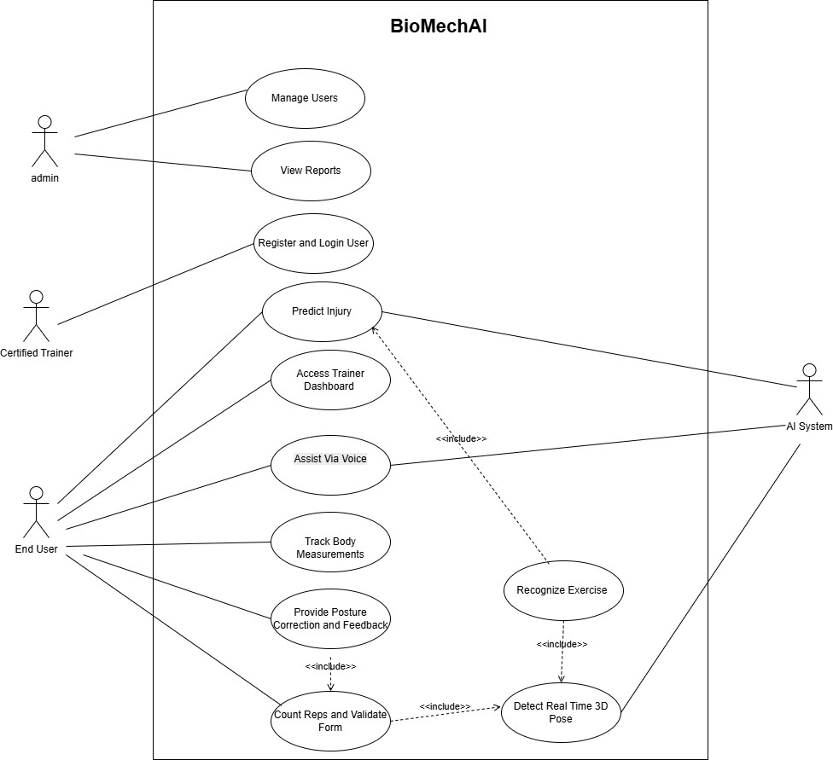
Figure 1: Use Case Diagram

- Expanded Use Cases:
Table 8: Register and Login User

Use Case ID | UC-01
Use Case Name | Register and Login User
Primary Actor | End User
Module | Module 1
Description | The user creates an account using email or social login and sets up a personal profile by entering body details.
Preconditions | The user has a smartphone with the BioMechAI app installed.
Postconditions | A user account is successfully created and stored in Firebase Authentication and Firestore.
Main Flow | - The user opens the app and selects the Register option.  - The user enters an email and password or chooses a social login method.  - The user provides body details such as height, weight, age, and fitness goal.  - The system calculates BMI and saves profile information in Firestore.  - The user is redirected to the home dashboard.

Table 9: Track Body Measurements

Use Case ID | UC-02
Use Case Name | Track Body Measurements
Primary Actor | End User
Module | Module 1
Description | The user records body measurements and tracks progress.
Preconditions | The user is logged in, and a profile exists.
Postconditions | Measurements are saved, and progress charts are updated.
Main Flow | - The user opens the Body Measurements section.  - The user selects Add Measurement.  - The user enters body measurement details.  - The system validates the entered data.  - The system calculates BMI and related metrics.  - The system saves the measurement record.  - The system updates and displays progress charts.

Table 10: Detect Real-Time 3D Pose

Use Case ID | UC-03
Use Case Name | Detect Real-Time 3D Pose
Primary Actor | End User
Module | Module 2
Description | The system captures live videos and detects body landmarks in real time to show a 3D skeleton overlay.
Preconditions | The user is logged into the app and has allowed camera access.
Postconditions | A skeleton overlay is shown on the camera screen in real time and joint movement data is stored in memory.
Main Flow | - The user starts a workout session.  - The camera begins capturing video at about 30 frames per second.  - MediaPipe Pose Lite detects 33 body landmarks with X, Y, and Z coordinates.  - The system displays a skeleton overlay on the live camera feed using OpenGL.  - Joint position data is stored in a 90-frame in-memory buffer for further analysis.

Table 11: Recognize Exercise

Use Case ID | UC-04
Use Case Name | Recognize Exercise
Primary Actor | AI System
Module | Module 2
Description | The AI system identifies the exercise being performed using pose data.
Preconditions | 3D pose tracking is active and the exercise model is loaded.
Postconditions | The exercise is identified and displayed to the user.
Main Flow | - The system receives joint data.  - The system collects movement data.  - The model analyzes the movement pattern.  - The model compares it with known exercises.  - The system selects the best matching exercise.  - The system returns the exercise type.  - The system displays the exercise name and confidence level.  - The system configures rep counting and posture settings.

Table 12: Assist Via Voice

Use Case ID | UC-05
Use Case Name | Assist Via Voice
Primary Actor | End User
Module | Module 3
Description | The voice assistant provides workout feedback and responds to voice commands.
Preconditions | The user is logged in, a workout session is active, and voice access is enabled.
Postconditions | Voice feedback is provided, and user commands are applied.
Main Flow | - The user starts a workout session.  - The system identifies the current exercise.  - The voice assistant provides exercise guidance.  - The system announces the rep count.  - The voice assistant gives form correction feedback.  - The user gives a voice command.  - The system processes the command and updates the session.  - The voice assistant confirms the action.

Table 13: Provide Posture Correction and Feedback

Use Case ID | UC-06
Use Case Name | Provide Posture Correction and Feedback
Primary Actor | End User
Module | Module 3
Description | The system monitors posture and provides real-time correction feedback.
Preconditions | The user is logged in, a workout session is active, and pose detection is running.
Postconditions | Posture feedback is provided, and session data is recorded.
Main Flow | - The user starts a workout and selects an exercise.  - The system loads the exercise posture template.  - The system tracks the user's body movements.  - The system compares posture with the ideal form.  - The system detects any posture errors.  - The system provides correction feedback.  - The system tracks reps and validate form.  - The system saves posture and feedback records.

Table 14: Count Reps and Validate Form

Use Case ID | UC-07
Use Case Name | Count Reps and Validate Form
Primary Actor | End User
Module | Module 3
Description | The system counts exercise reps and checks form quality.
Preconditions | A workout session is active. The exercise is identified. 3D pose tracking is running.
Postconditions | Rep count and form data are updated and saved.
Main Flow | - The system receives joint movement data.  - The system identifies the required joints.  - The system tracks joint movement.  - The system counts a rep when the movement is completed.  - The system checks the form for the rep.  - The system marks the rep as valid or invalid.  - The system updates the rep count and notifies the user.  - The system saves rep and form data.

Table 15: Predict Injury

Use Case ID | UC-08
Use Case Name | Predict Injury
Primary Actor | Certified Trainer
Module | Module 4
Description | The system analyzes workout data and predicts injury risk.
Preconditions | The user or trainer is logged in, and workout data is available.
Postconditions | The injury risk result and recommendations are saved and displayed.
Main Flow | - The trainer or user starts injury prediction.  - The system retrieves recent workout data.  - The AI model analyses the data.  - The system evaluates movement patterns and joint activity.  - The system calculates the injury risk level.  - The system identifies at-risk joints or muscles.  - The system generates recommendation of correct posture.  - The results are displayed on the dashboard.

Table 16: Manage User

Use Case ID | UC-09
Use Case Name | Manage User
Primary Actor | Admin
Module | Module 5
Description | The admin manages user accounts and profile information.
Preconditions | The admin is logged in, and user accounts exist.
Postconditions | User changes are saved and updated in the system.
Main Flow | - The admin logs in to the admin panel.  - The admin opens the User Management section.  - The system displays all registered users.  - The admin searches or filters users.  - The admin views a user's profile and activity.  - The admin updates or removes the user account.  - The system validates and saves the changes.  - The system shows a confirmation message.

Table 17: View Reports

Use Case ID | UC-10
Use Case Name | View Reports
Primary Actor | Admin
Module | Module 5
Description | The admin views and exports system reports.
Preconditions | The admin is logged in, and report data is available.
Postconditions | Reports are displayed and can be downloaded.
Main Flow | - The admin opens the Reports section.  - The system loads report data.  - The admin selects a report type.  - The admin applies the required filters.  - The system displays charts and report summaries.  - The admin reviews the report details.  - The admin exports the report as a PDF or CSV file.

Table 18: Access Trainer Dashboard

Use Case ID | UC-11
Use Case Name | Access Trainer Dashboard
Primary Actor | Certified Trainer
Module | Module 5
Description | The trainer views user progress and provides feedback.
Preconditions | The trainer is logged in, and assigned users exist.
Postconditions | Dashboard data is displayed, and trainer feedback is saved.
Main Flow | - The trainer logs in to the system.  - The system opens the Trainer Dashboard.  - The system displays assigned users.  - The trainer selects a user to view session details.  - The trainer reviews analysis results and progress data.  - The trainer adds feedback or recommendations.  - The system saves the trainer's notes.

- High-Level Use Case:
Table 19: High-Level Use Case

UC ID | Use Case Name | Primary Actor | Module | Brief Description
UC-01 | Register and Login User | End User | Module 1 | User registers via email, sets up profile with body metrics, and logs in to access the  system.
UC-02 | Track Body Measurements | End User | Module 1 | User logs body measurements such as weight, height, and BMI, and views historical trends over  time.
UC-03 | Detect Real Time 3D Pose | AI System | Module 2 | System captures video at 30 FPS and detects 33 body landmarks with X, Y, Z coordinates, rendering a 3D  skeleton overlay.
UC-04 | Recognize Exercise | AI System | Module 2 | AI model classifies the exercise being performed from real-time pose data and returns the exercise type to  calling modules.
UC-05 | Assist Via Voice | End User | Module 3 | The system delivers real-time audible workout cues and accepts voice commands during an active workout  session.

UC-06 | Provide Posture Correction and Feedback | End User | Module 3 | System analyzes user posture against ideal templates in real time and delivers on-screen and audible corrective  feedback.
UC-07 | Count Reps and Validate Form | End User | Module 3 | System counts exercise repetitions and validates whether each rep meets form quality thresholds using real-  time pose data.
UC-08 | Predict Injury | Certified Trainer | Module 4 | The AI model analyzes biomechanical and movement data to generate an injury risk score with  corrective recommendations.
UC-09 | Manage Users | Admin | Module 5 | Admin views, searches, edits, assigns roles to, or deactivates user accounts in  the system.
UC-10 | View Reports | Admin | Module 5 | Admin accesses system-generated usage, activity, and injury prediction reports with filtering and export  options.
UC-11 | Access Trainer Dashboard | Certified Trainer | Module 5 | Certified trainer views assigned users, reviews their workout data, session history, and can add notes or  recommendations.

- Swimlane Activity Diagram:

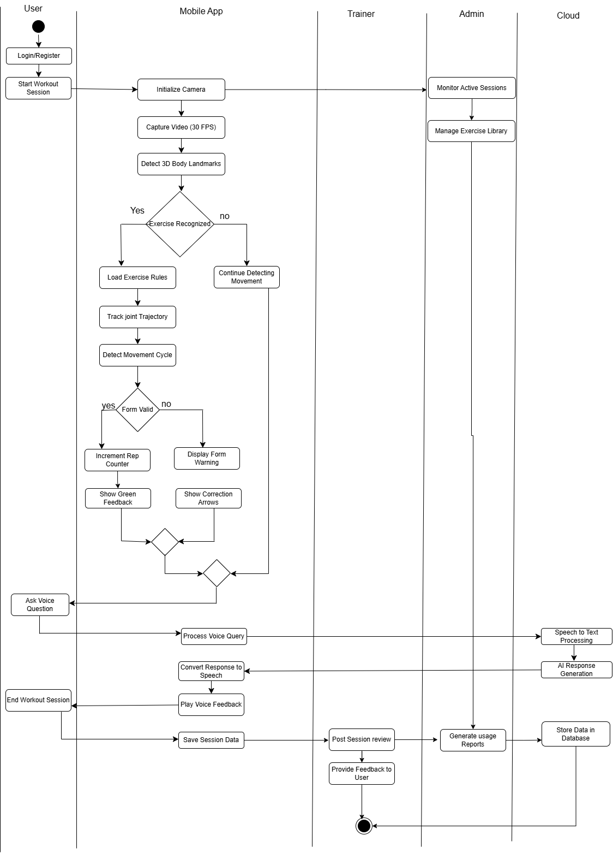

Figure 2: Swimlane Activity Diagram

- System Sequence Diagrams:
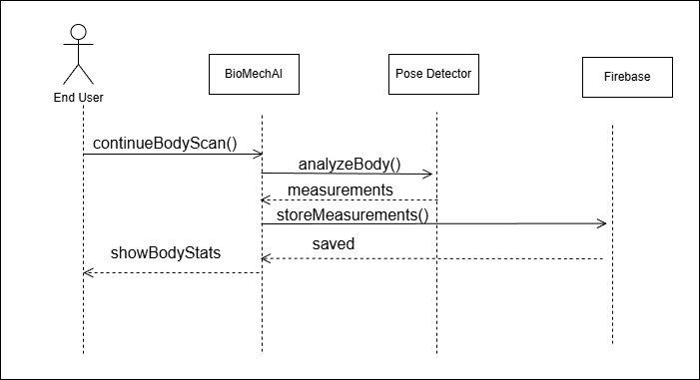
Figure 3: System Sequence Diagram 01 - Body Measurement Tracking
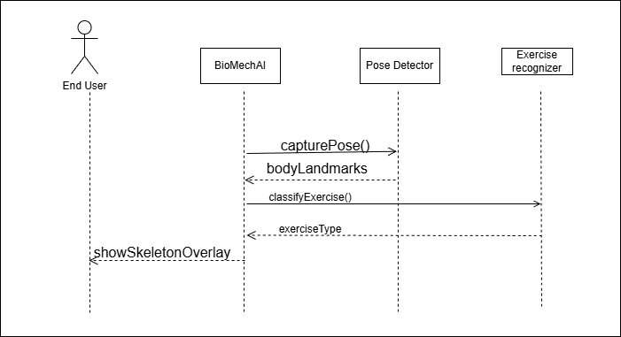
Figure 4: System Sequence Diagram 02 - Exercise Recognition

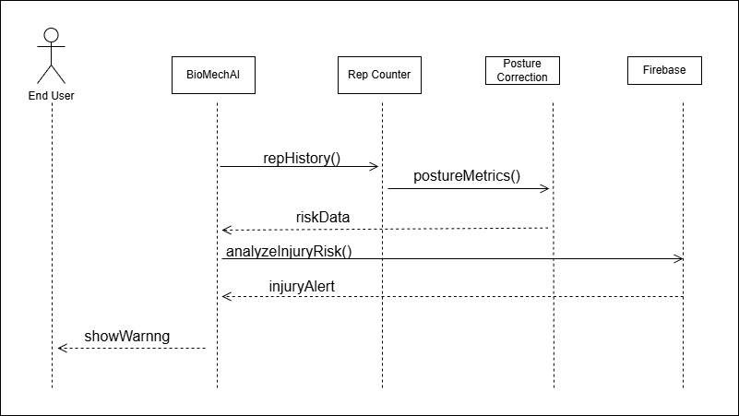
Figure 5: System Sequence Diagram 03 - Injury Prediction
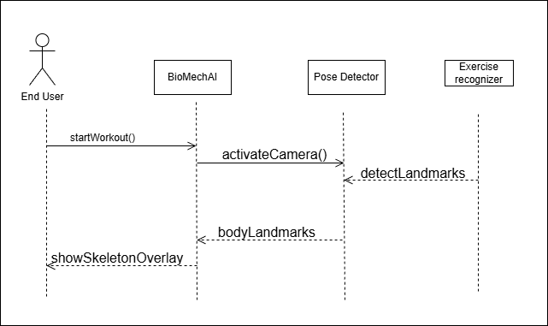
Figure 6: System Sequence Diagram 04 - Pose Detection

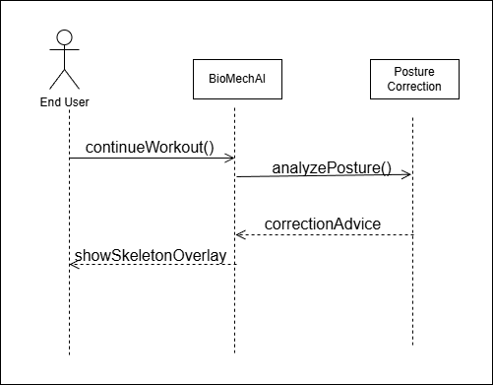
Figure 7: System Sequence Diagram 05 - Posture Correction
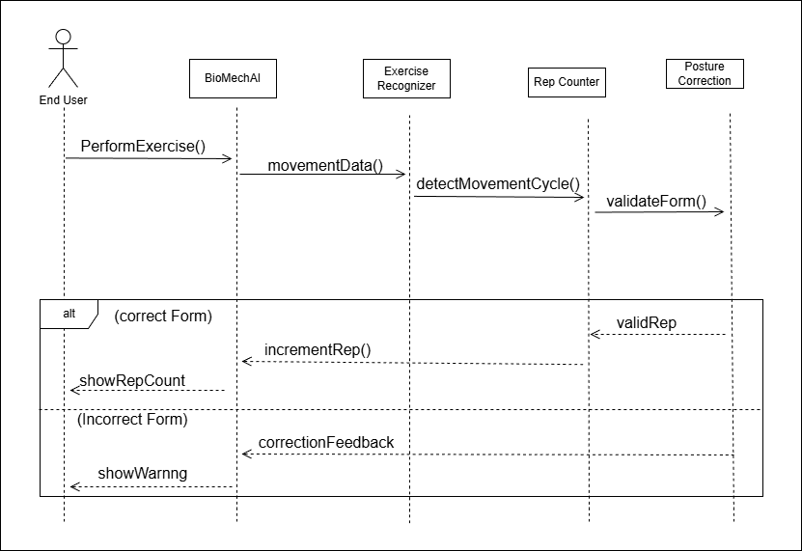
Figure 8: System Sequence Diagram 06 - Rep Counter

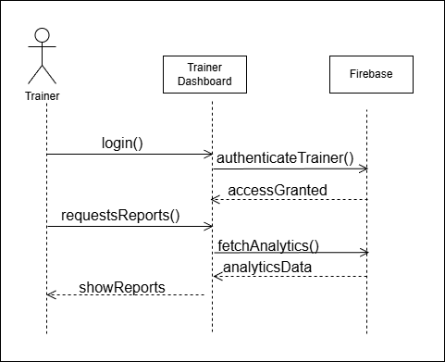

Figure 9: System Sequence Diagram 07 - Trainer Dashboard
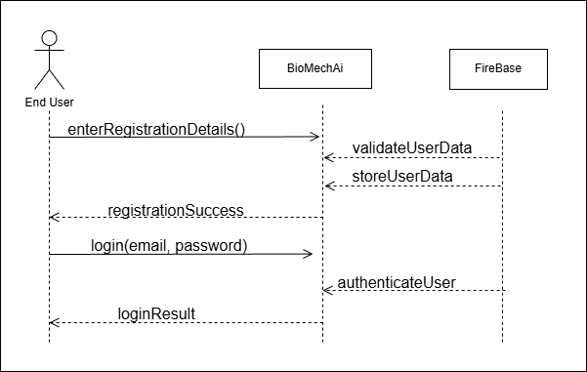
Figure 10: System Sequence Diagram 08 - User Registration and Login

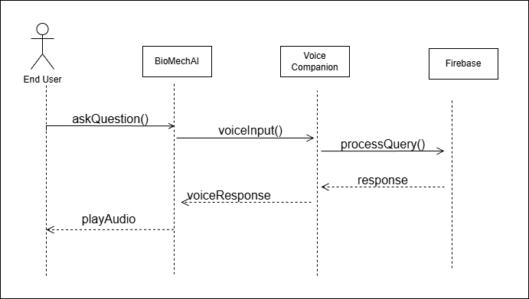
Figure 11: System Sequence Diagram 09 - Voice Companion

Structural Design:
- Domain Model:
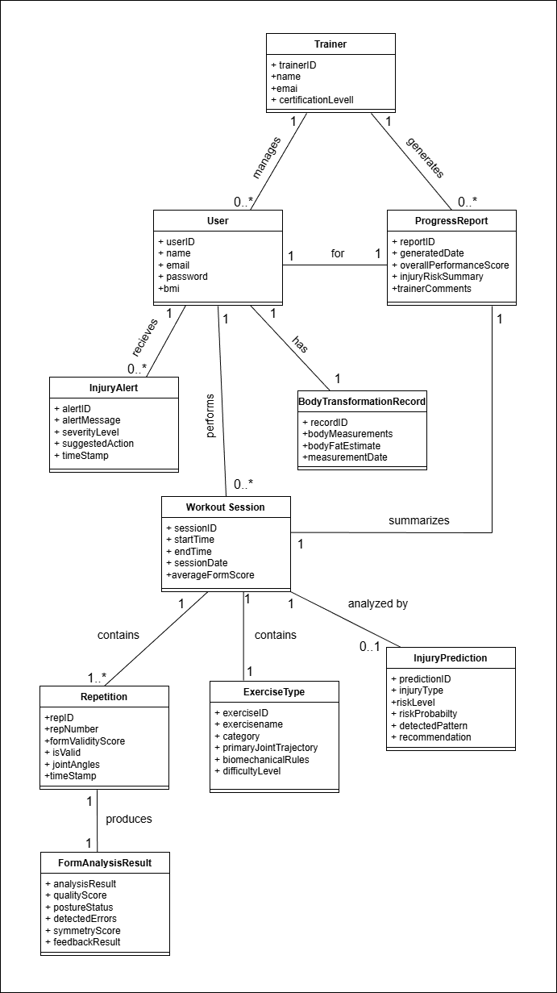
Figure 12: Domain Model

- Class Diagram:
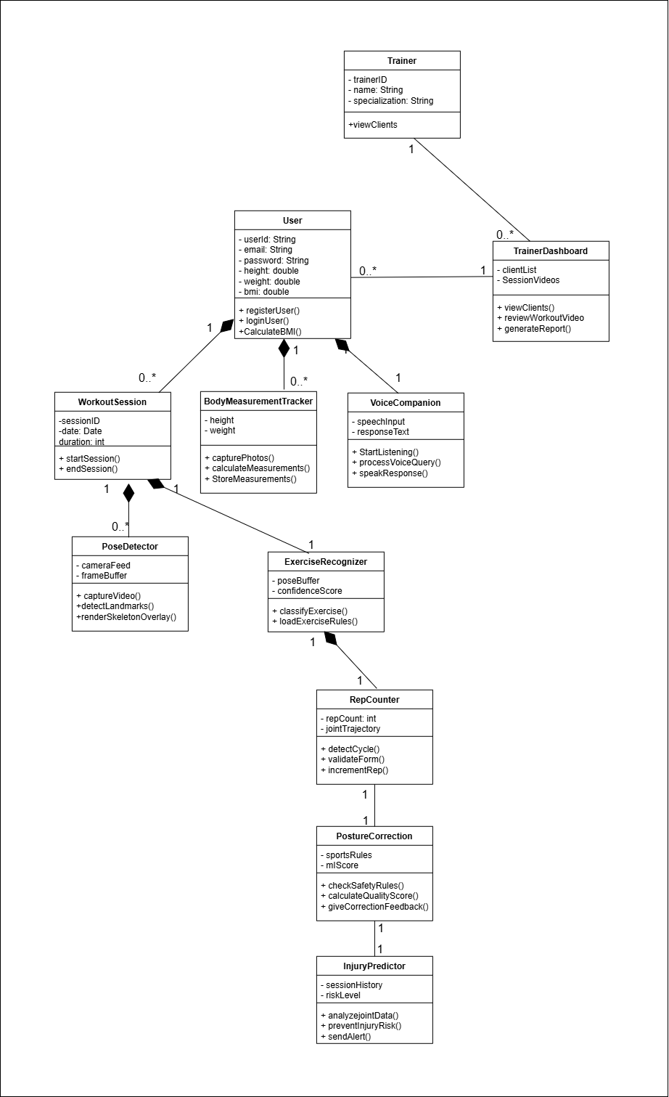
Figure 13: Class Diagram

- Component Diagram:
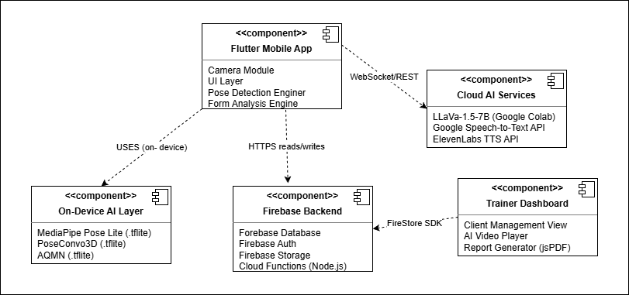
Figure 14: Component Diagram

Behavioral Design:
- Data Flow Diagram:
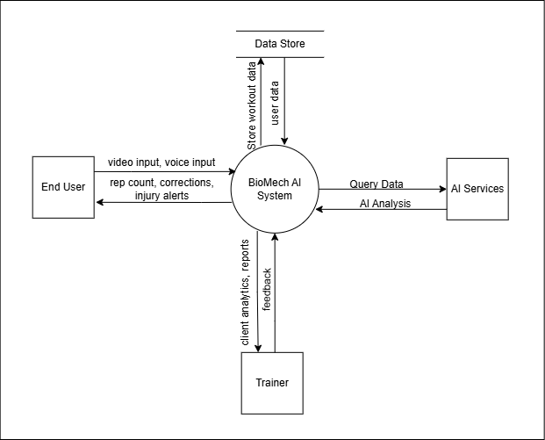
Figure 15: DFD Level 0
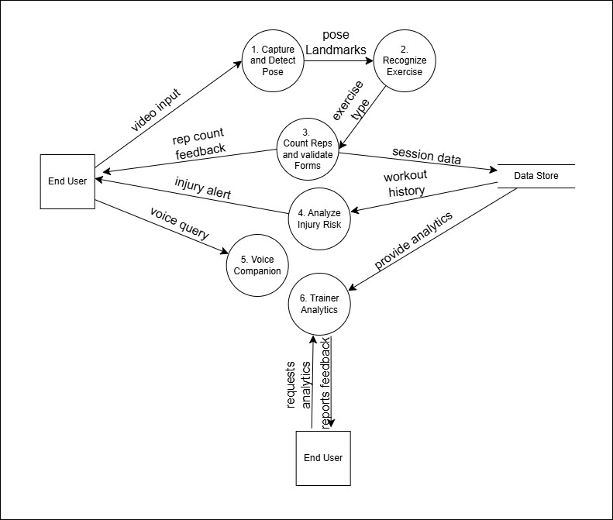

Figure 16: DFD Level 1

  - State Machine Diagram:
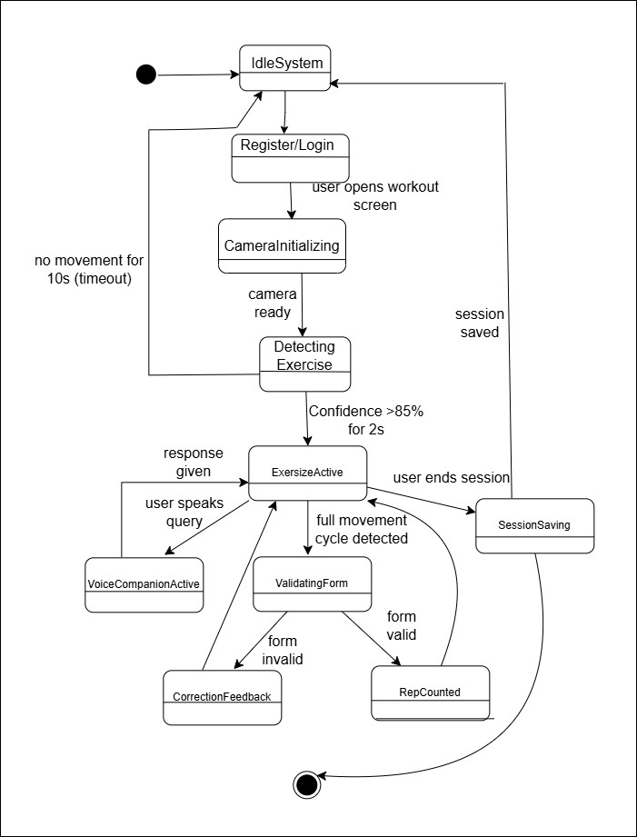
Figure 17: State Machine Diagram

- Sequence Diagram:

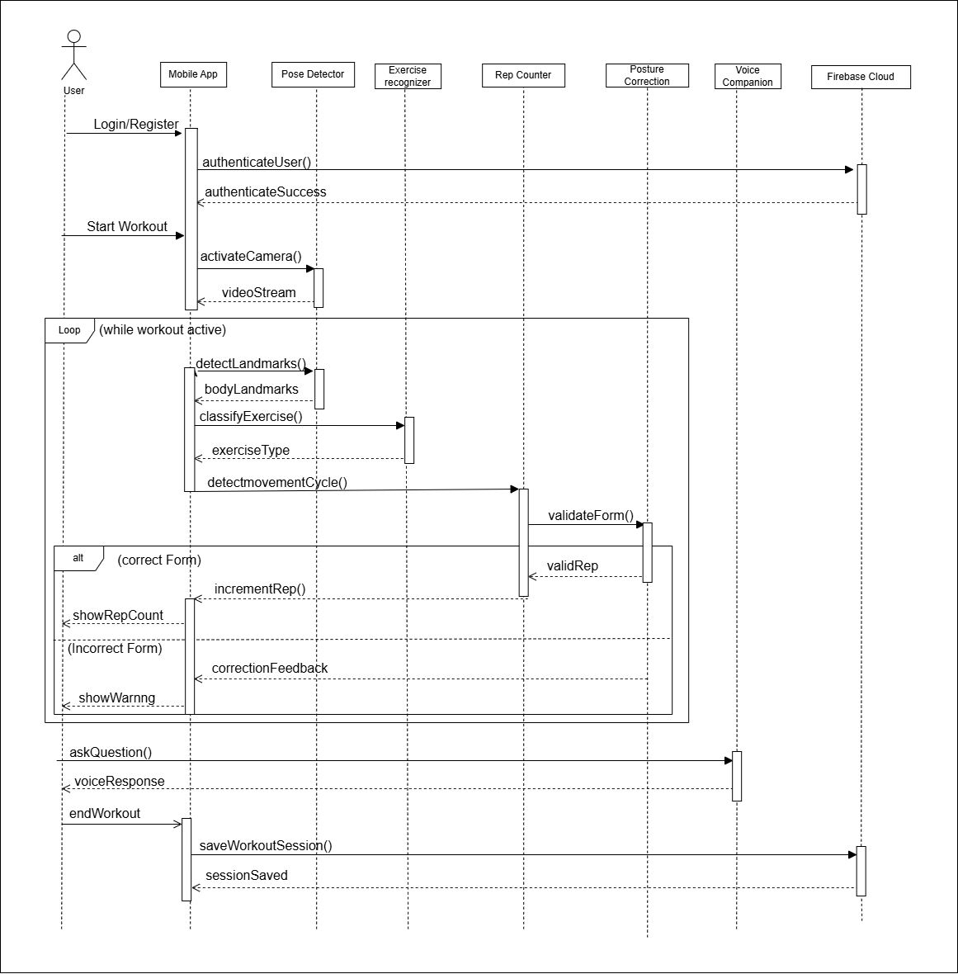
Figure 18: Sequence Diagram

Maintenance Phase:
- Deployment Diagram:
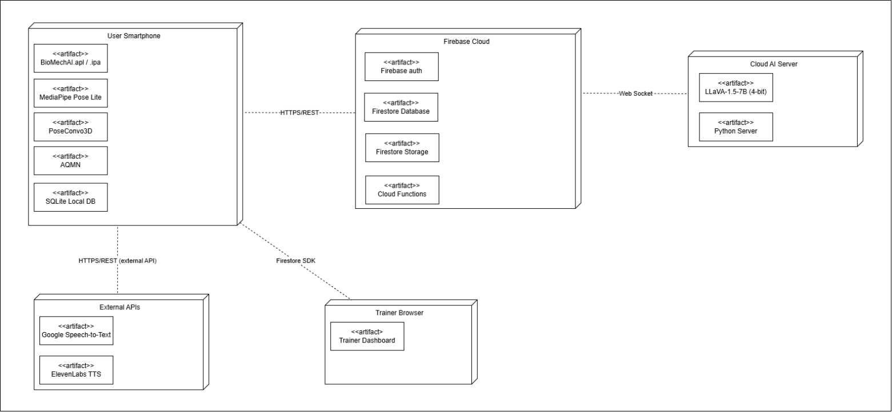
Figure 19: Deployment Diagram

The End

